Viruses in Infectious Disease Medicine
Ramsha Kudia
42882749
Spring
MCB5505

Table of Contents
Paramyxoviridae 3
Taxonomy 3
Virion Structure and Genome 3
Replication and Transcription 5
Diseases 6
Croup 6
Nipah Virus 8
Measles 10
Coronaviridae 10
Taxonomy 10
Virion Structure and Genome 11
Replication and Transcription 12
Diseases 13
SARS 13
Common Cold 14
Caliciviridae 15
Taxonomy 15
Virion Structure and Genome 15
Replication and Transcription 16
Diseases 16
Norwalk Virus 16
Reoviridae 17
Taxonomy 17
Virion Structure and Genome 17
Replication and Transcription 18
Diseases 19
Rotavirus 19
Colorado Tick Fever 20
Astroviridae 21
Taxonomy 21
Virion Structure and Genome 21
Replication and Transcription 22
Diseases 22
Gastroenteritis 22
References 24

Paramyxoviridae

Taxonomy
The family paramyxoviridae is part of the order mononegavirales, along with rhabodoviridae, filoviridae, and bornaviridae. The family is also divided into two subfamilies, paramyxovirinae and pneumovirinae. The subfamily paramyxovirinae contains five genera, avulavirus, henipavirus, morbillivirus, respirovirus, and rubulavirus. The genus henipavirus is made up of two viruses, the hendra virus and nipah virus. The genus contains the only family members that are zoonotic and highly pathogenic. The morbillivirus contains the measles virus, while the rubulavirus contains the mumps virus. Parainfluenza 2 and 4 are also part of rubulavirus and parainfluenza 1 and 3 are part of respiroviruses. The Human respiratory syncytial virus (RSV) is part of the subfamily pneumovirinae.

Virion Structure and Genome
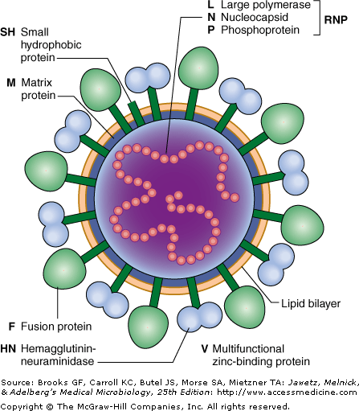
Figure 1: Diagram of paramyxovirus. Only some family members have the small hydrophobic protein.
The virion is encapsulated and has a pleomorphic structure, however, it is often spherical or filamentous. The fusion and glycoproteins are spikes on the envelope and the matrix proteins within the envelope stabilize the virion. There are three classifications for the glycoproteins; they can have hemagglutinin activity (H), both hemagglutinin and neuraminidase activity (H-N), or they can have neither (G). The helical nucleocapsid core is composed of the genome and polymerase. Paramxyoviruses are negative sense, non-segmented, single-stranded RNA viruses.

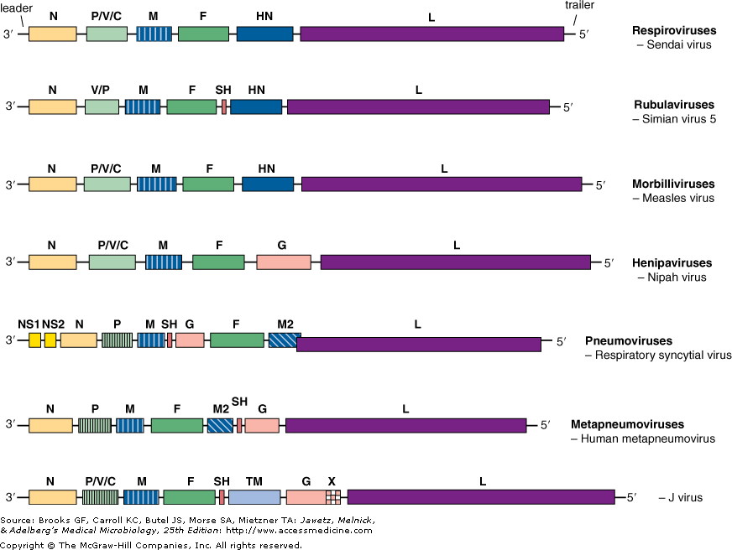
Figure 2: Gene maps for members of paramyxoviridae. The gene boxes are drawn approximately to scale.
The genome ranges in size from 15-19 kb in length, which contains 6-10 genes. Along with coding regions, the virus also contains non-coding regions. At the 3’ end, there is a leader sequence that is approximately 50 nucleotides in length and acts are as transcriptional promoter. There is a trailer sequence at the 5’ end that can is 50-160 nucleotides in length. The genes are also separated by non-coding regions, which are 3 nucleotides long for morbillivirus, respirovirus and henipavirus and are more variable in length for rubulavirus and pneumovirinae.
The N gene codes for the nucleocapsid gene that protects the virus from nuclease digestion. The P gene codes for a phosphoproteins, which along with N and L, forms the RNA polymerase complex (20). The P gene can also have different reading frames to code for accessory proteins, that even though they are not required for replication, may add virulence or aid survival. For example, the C protein regulates viral RNA synthesis and has shown to be a virulence factor. The M gene codes for the matrix protein, which stabilizes and maintains the virion structure. The F gene codes for the fusion protein; fusion of the envelope to the plasma membrane usually occurs at a neutral pH. The glycoprotein, coded by the G genes, facilitates cell entry. The L protein codes for the large polymerase which is the catalytic subunit of the RNA dependent RNA polymerase (RDRP).

Replication and Transcription
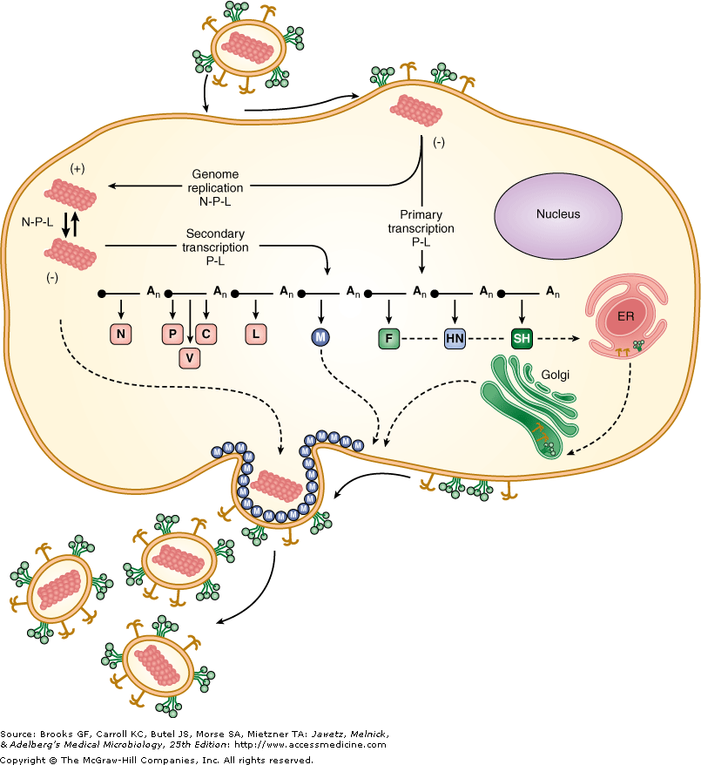
Figure 3: Schematic diagram showing the life cycle of paramyxovirus
The virus attaches to the cell surface using its glycoprotein (H/HN/G). Once the virus has attached, it fuses its envelope to the cell, releasing the ribonucleocapsid into the cytoplasm. Like many RNA viruses, replication occurs in the cytoplasm of the cell. Replication occurs when there is enough nucleoproteins in the cell to encapsidate the genome. Matrix proteins line the cytoplasmic side of the plasma membrane and the ribonucleocapsid interacts with the matrix protein and buds off, obtaining its envelope from the plasma membrane. During transcription, the RDRP binds to the genome at the leader sequence, and sequentially transcribes each gene. Each of the genes is flanked with start and stop codon. After an mRNA is made, it is capped and polyadenylated by the L protein.
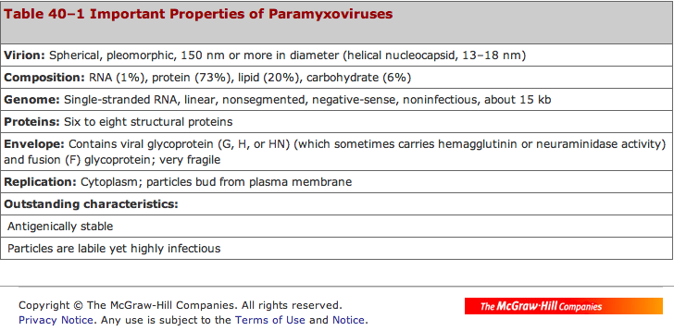

Diseases

Croup

Pathogenesis
Infection starts in the upper airway. Infection results in inflammation of the edema of the larynx, trachea, and bronchi. There is also an increased production of mucous, obstructing the airway. The narrowing of the subglottic trachea causes audible inspiratory stridor (8).

Symptoms
Croup can be caused by a number of paramyxoviruses, where some include, parainfluenza type 1 and 2, measles virus, and RSV. Incubation is approximately 2 to 6 days. Croup is characterized by loud cough, stridor, hoarseness, difficulty breathing, and fever (5).

Transmission
Croup is highly contagious and spread through droplet transmission. Croup can also be transmitted by fomites or direct contact.

Diagnosis
Most cases of croup are diagnosed based on symptoms described by the child’s parents. Sometimes, a doctor may even listen to the cough over the phone as a measure of diagnosis (27). To diagnose the disease, physicians may use a stethoscope to listen for breathing patterns, give a throat examination to look for a red epiglottis, or give a neck x-ray to find narrowing of the trachea.

Epidemiology
Croup is a common disease among children. Approximately 15% of the respiratory tract diseases are caused by one of the viruses. The disease is most common in children between the ages of 6 months to 3 years, however, it is seen in children younger than 6 months and those up to 16 years of age. The number of cases is greatest during fall and winter months.

Prevention and Treatment
It is hard to prevent the spread of croup since it is transmitted through the air, however, disinfecting surfaces can decrease the spread of the disease (27). Croup is treated with cool mist or steam therapy to dissolve the mucous. In more severe cases, doctors can prescribe oral corticosteroids such as prednisolone and dexamethasone to reduce swelling. Racemic epinephrine is also prescribed for reducing stridor if humidified oxygen is not effective (5).

Bronchiolitis

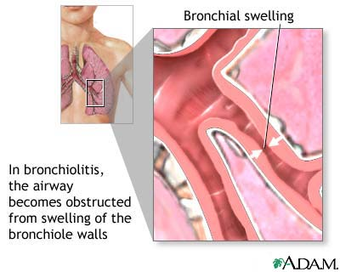
Figure 4: Figure shows swelling of the bronchial, leading to bronchiolitis

Pathogenesis
RSV causes Bronchiolitis. It enters the respiratory tract and infects the bronchioles.

Symptoms
Symptoms begin resembling the common cold, with runny and stuffy nose and a slight fever for the first few days, and progress to wheezing, difficulty breathing, rapid breathing, and rapid heartbeat.

Transmission
The virus is transmitted via aerosols, when an infected individual coughs, sneezes, or even talks. The virus can also survive on fomites. Sharing eating utensils or glasses can also lead to the spread of the disease.

Diagnosis
Physicians use a stethoscope to check for obstructed airways. More confirmative tests include, chest x-ray, blood test, and mucous samples.

Epidemiology
The disease is most often seen is children. 1-2% of infants who acquire the disease become hospitalized. Adults who develop the life-threatening disease have a history of cardiopulmonary disease, immunosuppression, premature birth, or bronchopulmonary dysplasia. Severe cases can lead to necrosis of respiratory epithelium, excessive mucous production, and edema.

Prevention and Treatment
There is no vaccine for bronchiolitis. Ways to prevent the spread of the virus include, hand washing, cleaning countertops, not sharing glasses, and avoiding direct contact with infected individuals. There is no specific treatment. Children are advised to say hydrated. Sometimes doctors ma prescribe ribavirin, however, there has been no evidence to suggest that it decreases the duration or severity of the illness.

Nipah Virus

History
The virus was first discovered in 1999 in Malaysia and there have been 12 outbreaks since then. The virus is named after a city where it was first seen. When the disease first appeared, people thought it was Japanese Encephalitis (JE) and authorities spent 5 months vaccinating people against JE and killing mosquitoes. There were some people that believed that the virus was hendravirus, which is a very close relative to nipahvirus, however, authorities and foreign physicians believed that the symptoms matched JE. Some features that made it different from JE were that it infected children more than adults, and there was a similar disease infecting pigs. The disease spread out of Ipoh to the city where it started taking out pig farms. After figuring out that pigs were transmitting the disease, one million pigs were shot and buried, destroying half the country's pig market. Scientist later found that one of the original locations of the outbreak in pigs was near the forest where there were fruit bats and the pig farms were surrounded by fruit trees. They then believed that the pigs became infected from the bats. Once they concluded that bats also carried the virus, the country began to panic, because the population of pigs could be controlled across borders, while bats could not.

Pathogenesis
The nipah outbreaks in pigs and other domestic animals (horses, goats, sheep, cats and dogs) were first reported during the initial Malaysian outbreak in 1999. The disease in pigs resulted in respiratory illness, while neurological symptoms were less common (24). Many of the pigs did not have any symptoms, but others developed acute feverish illness, labored breathing, and neurological symptoms such as trembling, twitching and muscle spasms. Generally, mortality was low except in young piglet. The incubation time for pigs 4-14 days and they were infectious during this time. Pigs spread the disease by coughing (9).
In humans, the virus targets microvascular endothelial cells. During autopsy, microscopic evaluations showed vasculitis, destruction of endothelial cells, and focal preivascular necrosis in the small vessels near the lung, heart, and kidney. The most severe damage was seen in blood vessels near the central nervous system. The microvasucular blood vessels of several organs also exhibited syncytia or multinucleated giant endothelial cells, accompanied by vascular inflammation, which was not a feature of other viral encephalides (7).

Symptoms
The incubation period ranges from 4 to 18 days, however, the onset of symptoms can range from 24 hours to 1 month. The symptomatic to asymptomatic ratio is 3:1. The symptoms start off similar to influenza and are fever, muscle pain, and headache. Some more severe symptoms include pneumonia, seizures, abnormal papillary reflexes, absent doll's eye reflex, profound tachycardia, hypertension, tremor, dysarthria, and systemic infection in rare cases. There is also a reduced level of consciousness, disorientation, and inflammation of the brain. Encephalitis can be acute or late onset, where acute can result in relapse (24).

Transmission
The predominant family of bats that transmit the disease was Pteropodidae, which were fruit bats. The bats aggregate with a density of more than 3,000 bats/m2, in population of up to several million individual animals. Bats are also long distance flyers, with some species travelling up to 640 km during seasonal migration. Migratory bats have been shown to exchange novel viruses with non-migratory ones (7).
The transmission can be from bats to pigs, bats to humans, pigs to humans, or human to human. Bat saliva on fruit infects humans, pigs, and other animals. The virus was also spread in hospital settings due to improper use of equipment. The disease also has the possibility of being spread by aerosols.

Diagnosis
The disease is diagnosed by immunofluorescence assay and virus isolation by cell culture and confirmed by serum neutralization, ELISA, and PCR.

Epidemiology
There have been outbreaks almost every year since the virus was discovered. The virus has become a problem in Bangladesh. Outbreaks in of the Nipah Virus have seasonal pattern in South Asia and there is a limited geographical distribution. The geographic distribution of nipah virus overlaps with that of Pteropus genus of bats.

Prevention and Treatment
There is a vaccine being developed. Recent studies have shown a recombinant sub-unit vaccine formulation protects against lethal nipah virus in cats. The virus is easily killed with bleach of detergents such as sodium hypochorite. To prevent the spread of the disease, pig farmers should quarantine suspected animals and avoid direct contact. Fruit should be washed and peeled before consumption, especially in areas where the virus is present. People should also boil date palm oil, since it has been shown to be frequently contaminated. Treatment is mostly focused on managing fever and the neurological symptoms. Ribavirin is used to treat symptoms such as nausea, vomiting, and convulsions.

Measles

Pathogenesis
Even though there is a vaccine available, measles still causes many deaths worldwide. The measles virus infects cells that line the back of the throat and lungs.

Symptoms
The incubation time for the virus is 10 to 12 days. The disease presentation begins with high fever that lasts from 4 to 7 days. Some other initial symptoms include runny nose, cough, red and watery eyes, and small white spots on the inside of the cheeks. Several days later, a rash appears, usually beginning on the face and upper neck (23). The rash then spreads to other parts of the body like hands and feet. Some more serious complications include serious blindness, encephalitis, severe diarrhea and related dehydration, ear infections, or severe respiratory infections such as pneumonia.

Transmission
The virus is spread through the air when infected individuals cough sneeze. The virus can also be spread by direct contact. The virus can survive outside the body for up to 2 hours.

Diagnosis
Measles is diagnosed by antibody detection. The most common method of diagnosing measles in labs is by enzyme immunoassay (EIA).

Epidemiology
Most of the measles cases occur in low-income countries. Many of the deaths associated with measles are in children under the age of 5 years. Because of the vaccine, the number of measles has decreased by 78% since the year 2000 (23).

Prevention and Treatment
Getting the vaccine can prevent measles. The vaccine has been available for over 40 years. There is no treatment for measles, besides rehydration.

Coronaviridae

Taxonomy
Coronaviridae is part of the order Nidovirales, and is made up of two subfamilies. The subfamily coronavirinae consists of three genera, alphacoronavirus, betacoronavirus, and gammacoronavirus. The subfamily includes the severe acute respiratory syndrome (SARS) virus and the strain 229E, which causes the common cold. The other subfamily, torovirinae, infects many different animals, although the viruses are not considered very pathogenic to humans (11).

Virion Structure and Genome
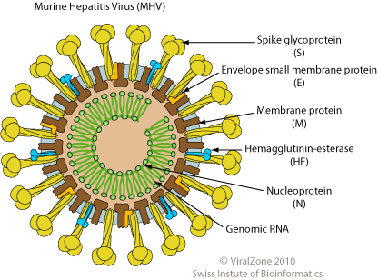
Figure 5: Diagram of coronavirus, specifically the Murine Hepatitis Virus. The HE protein is only seen in some family members.
The coronaviruses are described by their crown like appearance when observed under an electron microscope. The virus is encapsulated and has a helical capsid. The virus is spherical and approximately 120nm in diameter (11).
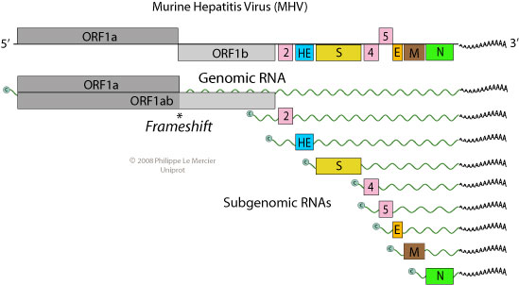
Figure 6: Schematic diagram showing the genome of MHV, including the different frame shifts and subgenomic RNAs.
The coronaviruses have the largest genome out of all the RNA viruses at 27-32 kb at length. The coroncavirus genome is positive-sense, linear, single stranded RNA. The RNA is infectious, has a cap at the 5’ end, and has a poly A tail at the 3’ tail. After the 5’ cap, there is a leader (L) sequence, approximately 75 bp in length. There is also a leader sequence present at the 5’ end of all subgenomic RNAs. There are 7 to 14 different ORFs. The N gene codes for the nucleocapsid, which associates with the RNA. The E gene codes for the envelope. The M gene codes for the membrane protein, which spans the membrane three times and is involved in RNA packing. The spike proteins, coded by the S gene, attach to cell receptors and cause the virus to fuse with its host. Hemagglutinin-esterase, coded by the HE gene and only present in some coronaviruses, plays a part in entry and release.

Replication and Transcription
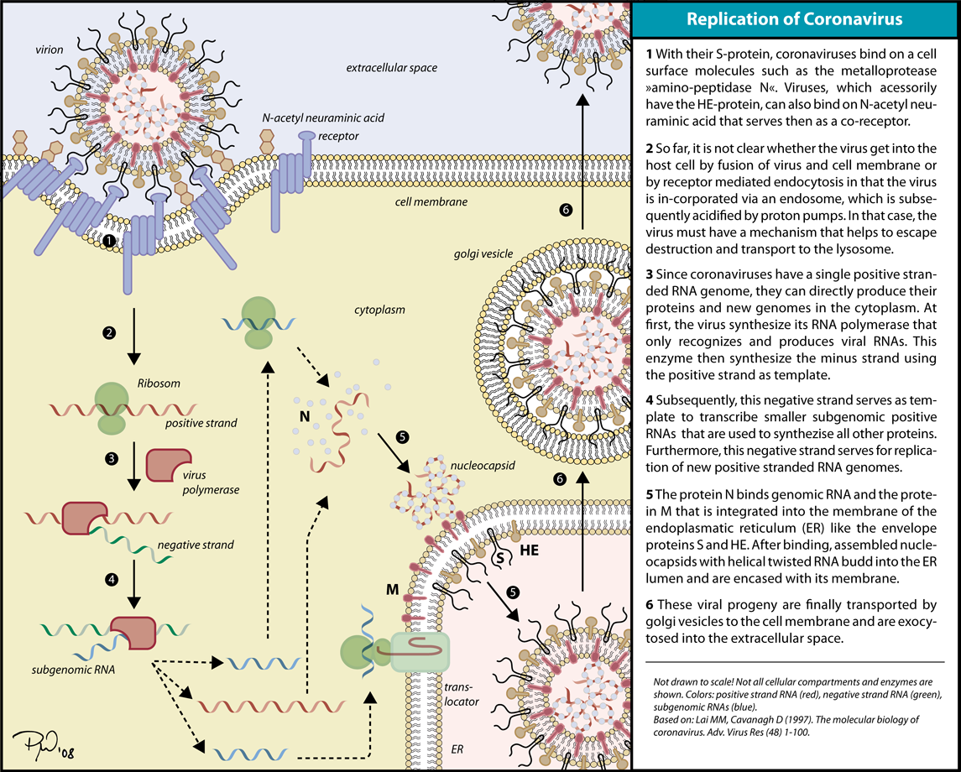
Figure 7: Diagram showing and describing the replication of coronaviruses
The virus attaches to cell receptors by S proteins, or HE if they are present, and is endocytosed. When the viral membrane fuses with the vesicle membrane, the RNA is released in the cytoplasm. Replicase is then synthesized and produces the (-) ssRNA. The (-)ssRNA then serves as a template genomic and subgenomic RNA. Structural proteins are then made with the subgenomic RNA. The virus is assembled at the ER and Golgi. The virions are transported from the Golgi and released from the cell (11).

Diseases

SARS

Pathogenesis
The SARS virus has been isolated form a variety of organs, including lung and kidneys. The natural host for the virus was found to be bats. Even though there has not been a SARS case in over 5 years, the disease is not considered eradicated because it still exist in animals (11).

Symptoms
Some common symptoms include high fever, chills, rigors, headache, dizziness, malaise, and myalgia. Some other symptoms such as sputum production, sore throat, coryza, nausea, and vomiting are less common, however are seen in a number of cases (25). Some severe cases develop to pneumonia.

Transmission
SARS is primarily spread through droplets and direct contact with infected individuals. It is possible to acquire the disease via fecal-oral route, but it is less common.

Diagnosis
The viral RNA can be detected in the plasma. Most labs diagnose the disease by using PCR or rt-PCR. ELISA, immunofluorescence assay, and neutralization test can also be used to confirm the diagnosis.

Epidemiology
The first case of SARS was in November 2002. After that, cases of pneumonia-like symptoms appeared in South-East Asia in Indonesia, Thailand, Vietnam, Singapore, the Philippines, and in Canada. In March the following year, WHO labeled SARS as a worldwide threat, and the disease had spread to the United States and Europe. It only took the virus a few months to infect the entire globe. There were over 8000 possible cases, and 20% of the cases were related to health care workers (25). The virus was infecting healthy people, between the ages of 24-70.

Prevention and Treatment
There is no vaccine for SARS. In order to prevent the spread of the disease, people should stay away from infected individuals. Healthcare workers should also practice take proper measures and reduce the number of nosocomial infections. There are many different antivirals prescribed, even though there is little evidence for its effectiveness. Some antivirals include, ribavirin, neuraminidase inhibitor (such as Tamiflu), protease inhibitor (such as Kaletra), and human interferons.

Common Cold

Pathogenesis
Coronavirus causes the second most causes of common cold, right after rhinoviruses. The virus infects the upper respiratory tract, including the nose and throat.

Symptoms
Incubation time for the virus is 1 to 2 days. Some common symptoms include, runny or stuffy nose, itchy or sore throat, cough, congestion, slight body aches or a mild headache, sneezing, watery eyes, low-grade fever, and mild fatigue. Symptoms can last 1-2 weeks (4).

Transmission
The virus can is spread through droplets transmission. When someone who is infected coughs, sneezes, or talks, droplets are released into the air. The virus can also be spread through direct contact or fomites.

Diagnosis
Diagnosing the common cold can be difficult since many symptoms resemble the flu.
COMPARING COLDS AND FLUS
Symptoms | Cold | Flu
Fever | Rare | Common and high (102 - 104 F); lasts 3 - 4 days
Headache | Rare | Almost always present
General aches and pains | Mild, if they occur at all | Often severe
Fatigue, exhaustion, and weakness | Mild, it they occur at all | Extreme exhaustion is early and severe; can last 2 - 3 weeks
Stuffy nose | Nearly always | Sometimes
Sneezing | Very common | Sometimes
Sore throat | Common | Sometimes
Chest discomfort and cough | Mild-to-moderate, hacking cough | Common, can be severe
Source: National Institute of Allergy and Infectious Disease

Epidemiology
The common cold is seen in all age groups, and most prevalent in pre-schools. The disease has a seasonal pattern, where most cases are seen in fall and winter months.

Prevention and Treatment
Since there are many viruses that can cause the common cold, there is no vaccine. Ways to prevent the spread of the disease include, hand washing, using tissue, not sharing eating utensils or glasses, and avoiding contact with infected individuals. There is no cure for the common cold. Symptoms usually go away with rest, however, some people take over the counter medication to treat symptoms, even though there is no evidence that it decreases the length of the disease.

Caliciviridae

Taxonomy
In humans, the calicivirus causes inflammation of the intestines and stomach. Caliciviridae consists of four genera, vesivirus, lagovirus, norovirus, and sapovirus. The genus norovirus contains the Norwalk virus responsible for enteric infection.

Virion Structure and Genome
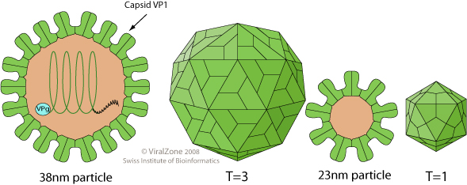
Figure 8: Diagram of the structure of a caliciviridae (21)
The calici virion is non-enveloped and icosahedral in shape. The virion also has T=3 symmetry and is composed of 180 capsid proteins. The diameter of the virus is approximately 27-40nm.
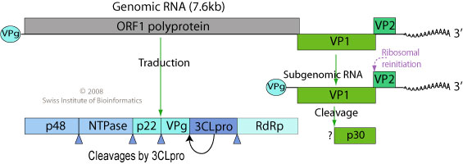
Figure 9: Schematic diagram of the caliciviridae genome (21)
The genome of calicivirus is positive-sense, monopartite, linear, single-stranded RNA. The genomes size it between 7.3 and 8.3 kb. The 5’ end of the genome contains a VPg protein and the 3’ end has a poly A tail. The naked RNA is infectious. ORF1 codes for the nonstructural proteins and VP1 and VP2 code for the capsid protein and minor structural protein, respectively.

Replication and Transcription
Like most RNA viruses, replication takes place in the cytoplasm. The virus starts by attaching to host receptors, where it becomes internalized. Uncoating of the virus leads to RNA being released into the cytoplasm, where VPg is removed from the RNA. ORF1 is then translated, producing nonstructural proteins that are involved in transcription (21). The negative sense RNA is made, which is used as a template for genomic and subgenomic RNA. The negative strand also codes for structural proteins. The virions are then assembled and released out of the cell (21).

Diseases

Norwalk Virus

Pathogenesis
Humans are the only source of the virus. The virus is also not able to survive outside of a human host for a long time. The virus infects the stomach and small intestines.

Symptoms
Symptoms begin to appear 24-48 hours infection. The most common symptoms are nausea, vomiting, diarrhea, abdominal pain, muscle aches, headache, tiredness and low-grade fever. Symptoms usually last for a couple days and subside on their own (2).

Transmission
The virus is transmitted via the fecal-oral route. People can acquire the disease by consuming contaminated food or water. The virus can also be found in oysters that were contaminated with sewage.

Diagnosis
The virus is usually diagnosed by symptoms, however the most common laboratory technique is testing the blood for antibodies.

Epidemiology
There are approximately 200,000 cases of Norwalk virus each year in the United States, and by the age of 50, 60% of Americans have been exposed to the virus (14).

Prevention and Treatment
There is no vaccine for the virus. Reducing the spread of the disease is accomplished by proper food handling, hand washing, and cooking food properly. There is no treatment for the disease, except to remain hydrated.

Reoviridae

Taxonomy
There are many species of reoviruses, infecting humans, insects and plants. The viruses usually infect the respiratory and gastrointestinal tract, showing no symptoms in humans. The family reoviridae contains many genera, including orthoreovirus, orbivirus, rotavirus, coltivirus, seadornavirus, aquareovirus, idnoreovirus, cypovirus, fijivirus, phytoreovirus, oryzavirus, and mycoreovirus, where rotavirus is known to cause severe diarrhea in infants and coltivirus causes Colorado Tick Fever (CTF) (6).

Virion Structure and Genome
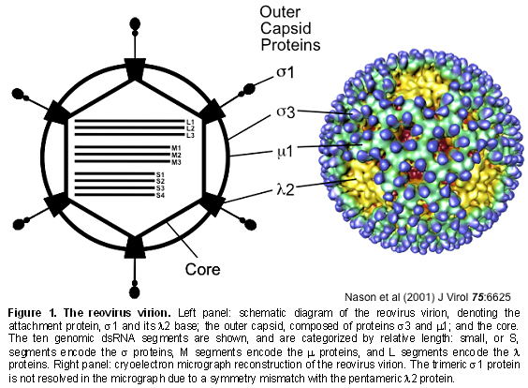
Figure 10: Schematic diagram of reoviridae, showing the outer capsid proteins and the core (16)
The virion is non-enveloped and has icosahedral capsids (T=13). The virion also has a double protein shell, with a diameter of 80nm for the outer shell and 60nm for the inner shell. The genera are serologically unrelated. The genome consists of 10-12 segments of double stranded RNA.

Replication and Transcription
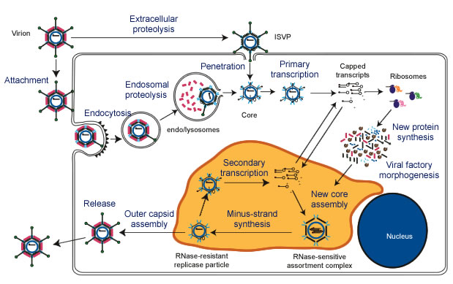
Figure 11: Image shows the replication of reoviridae
The reoviruses, like most RNA viruses, replicate in the cytosol of cells. The virus penetrates the plasma membrane and the viral core transcribes the genome segments. The genome codes for 12 viral proteins, 8 of which are structural while the other 4 are nonstructural (16). The nonstructural protein μNS makes the matrix of the viral factories. These matrices are where new cores are made and where second rounds of transcription occur. The cores are coated the outer capsid proteins μ1, σ3, and σ1. Once the intact virions are formed, they are released through cell lyses.

Diseases

Rotavirus

Pathogenesis
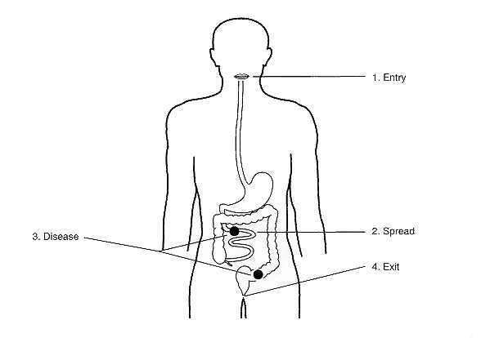
Figure 12: Schematic diagram showing the entry, spread, disease, and exit of rotavirus.
The rotavirus infects epithelial cells that line the upper small intestine, causes cell death, and decreases production of digestive enzymes. The small intestine returns to normal after weeks

Symptoms
Rotavirus has an incubation time of less than 48 hours. Some of the common symptoms are slight fever, vomiting, and profuse watery diarrhea. The symptoms can last for a week. Severe complications are caused by dehydration.

Transmission
The virus is transmitted via the fecal-oral route. Rotavirus is very stable and can survive in the environment for an extended period of time. People can acquire the virus ingesting contaminated food and water or from contaminated surfaces.

Diagnosis
Rectal or fecal swabs can be used to diagnose rotaviral gastroenteritis. This can done by a variety of methods including, electron microscopy, radioimmunoassay, immunofluorescence, inoculation of tissue cultures, latex agglutination, reverse passive hemagglutination assay, polyacrylamide gel electrophoresis, dot hybridization, polymerase chain reaction, and enzyme-linked immunosorbent assay (ELISA) (15). Most labs use ELISA to diagnose the virus.

Epidemiology
Rotavirus is more often seen in young children and infants. Adults are rarely infected, and cases revolve around parents with infected children, the elderly, and immunocompromised. Rotavirus is endemic worldwide. It is one of the leading causes of death in infants in developing countries (15). Even in the United States, rotavirus is seen year round, with epidemics from November to April. The epidemics usually start at the west coast and move east. The virus most often affects infants under the age of 24 months, and by the age of 3 years, most children have already had the virus once.

Prevention and Treatment
There is a vaccine, Rotarix®, to prevent the disease in infants. The vaccine is taken in two doses, at 2 and 4 months. Other methods of preventing the disease are proper handling of food and water sources. There is no specific treatment for the infection. Sick individuals are advised to stay hydrated.

Colorado Tick Fever

Pathogenesis
The virus infects the hemopoietic cell, especially erythrocytes. When the virus infects bone marrow cell, it decreases the production different blood cell types and may cause thrombocytopenia (3).

Symptoms
The incubation period of the infection is about 3-6 days. Infection begins with a fever that last for approximately 3 days that goes away, and comes back after 1-3 days for another few days. Some other symptoms besides fever include general weakness, headache (especially behind the eyes), muscle aches, nausea and vomiting, rash (light-colored or red and raised), photophobia (sensitivity to light), and sweating (3). In more serious cases, there may be complications such as aseptic meningitis, encephalitis, or hemorrhagic fever.

Transmission
The virus is transmitted by a tick bite. There have not been any human-to-human related cases, except for a few rare blood transfusion cases because the virus can remain in the blood for up to four months after the infection. The wood tick, Dermacentor andersoni, carries the virus and can transmit the disease to anyone who comes into contact with the tick.

Diagnosis
There are many tests that can be used to confirm an infection. Some methods include complement fixation antibody test and immunofluorescence antibody test. Some other tests used to confirm the infection include complete blood count (CBC), reatine kinase, and liver function tests.

Epidemiology
D. andersoni is the most prevalent tick in the rocky mountain region. Most cases of Colorado Tick Fever (CTF) are seen from March to September, however, cases usually occur in April, May, and June. CTF is also more common in Colorado than Rocky Mountain Spotted Fever. About 15% of campers in Colorado have been exposed the disease. The prevalence of the disease is far less in other parts of the country (3).

Prevention and Treatment
There is no vaccine to prevent the disease. In order to avoid getting the disease, those walking outdoors in tick-infested areas should wear closed toed shoes, long sleeves, pants, and minimize exposed skin. People should also wear light colored clothing since ticks are harder to spot on dark colored clothes. Insect repellent, especially DEET, can also be useful in avoiding ticks.
There is no specific treatment after being bit by a tick. The tick should be removed carefully with tweezers to prevent spread of the virus. Pain relievers and other medication can be used to treat the symptoms.

Astroviridae

Taxonomy
Astroviruses were first discovered in 1975 by using electron microscopy. There was an outbreak in a Scottish city, and they virus was found in both children and adults. The family astroviridae is divided into two genera, mamastrovirus, which contains the human astrovirus, and avastrovirus (13).

Virion Structure and Genome
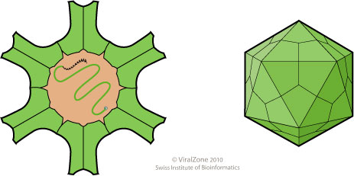
Figure 13: Diagram showing the structure of astroviridae (19)
The virus is non-enveloped, spherical, and has an icosahedral capsid. The virus is small, with a diameter of 28 to 30nm. There are small surface projections, which make it appear rough. There are 12 vertices on the virion from where the spikes protrude. The astrovirus genome consists of positive-sense, linear, monopartite, single-stranded RNA. The genome is approximately 6.8-7 kb in length and has a poly A tail at the 3’ end.
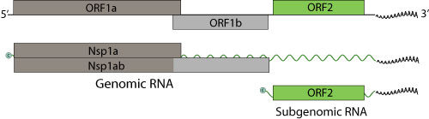
Figure 14: Schematic diagram of the genome of astroviridae (19)
The viral RNA can be infectious and it acts both as the genome and messenger RNA. ORF1a codes for the viral protease, while ORF1b codes for the viral polymerase. ORF2 represents the subgenomic RNA and codes for the capsid protein (13).
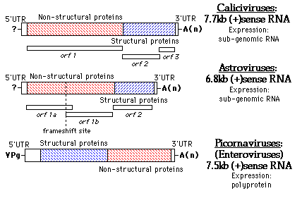
Figure 15: The diagram compares the genome, genes, and type of expression for calicviruses, astroviruses, and picrornaviruses

Replication and Transcription
The virus attaches to a host by using gylcoproteins. Like most RNA viruses, replication takes place in the cytoplasm. The virion is uncoated and the RNA is released into the cytoplasm of the host. The RNA is then transcribed into two polyproteins. The positive strand is used to make a negative sense stands, which serves as a template for replication. The subgenomic RNA is then translated to give rise to the capsid proteins. The virus is then released from the cell and matures by proteolytic cleavage.

Diseases

Gastroenteritis

Pathogenesis
Even though astrovirus causes many cases of gastroenteritis worldwide, there is little known about its pathogenesis. Astrovirus can cause the destruction of intestinal epithelial cells, modulation of ion channels or intestinal disaccharides activity, which leads to malabsorption. It can also cause induction of intestinal epithelial barrier permeability.

Symptoms
Incubation of the virus is usually 1 to 2 days and symptoms can last up to 10 days. The primary symptoms of gastroenteritis are watery diarrhea and vomiting. Some other symptoms include headache, fever, and abdominal cramps.

Transmission
The virus is transmitted via the fecal-oral route. It can also be spread by close contact, or contaminated food and water. The disease can also be transmitted by eating seafood that has been contaminated with the virus. Most cases are seen in day care setting, of within family units.

Diagnosis
Different ways of diagnosing the disease include electron microscopy, ELISA, immunofluorescence, and PCR. These techniques can detect the virus particle, or antigens or viral nucleic acid in stool samples.

Epidemiology
The human astrovirus is endemic worldwide. By the age of 9 years, most children in the United States have antibodies to astrovirus, indicating that it may be asymptomatic in most children. The disease affects people worldwide and the illness is most common in children under the age of 2.

Prevention and Treatment
There is no vaccine or specific anti-viral treatment for the virus. People with the virus should stay hydrated. The spread of the disease can be reduced by proper handling of food, hand washing, and avoiding infected individuals.

References
- Baron, Samuel. Medical Microbiology. Galveston, TX: University of Texas Medical Branch at Galveston, 1996.
- "CDC - Norovirus: FAQ." Centers for Disease Control and Prevention. Center for Disease Control. Web. Apr. 2011. <http://www.cdc.gov/ncidod/dvrd/revb/gastro/faq.htm>.
- "Colorado Tick Fever: MedlinePlus Medical Encyclopedia." National Library of Medicine - National Institutes of Health. National Institutes of Health. Web. Apr. 2011. http://www.nlm.nih.gov/medlineplus/ency/article/000675.htm
- "Common Cold." Mayo Clinic. Mayo Foundation for Medical Education and Research. Web. Apr. 2011. <http://www.mayoclinic.com/health/common-cold/DS00056>.
- "Croup Treatment, Symptoms, Cause, Medication and Incubation Period by MedicineNet.com." MedicineNet. Web. Apr. 2011. <http://www.medicinenet.com/croup/article.htm>.
- "Family Reoviridae - Hierarchy - The Taxonomicon." The Taxonomicon. Universal Taxonomic Services. Web. Apr. 2011. <http://taxonomicon.taxonomy.nl/TaxonTree.aspx?id=37>.
- Fong, I. W., and Ken Alibek. New and Evolving Infections of the 21st Century. New York, NY: Springer, 2007. 279-93.
- Human parainfluenza viruses (common cold and croup). Centers for Disease Control and Prevention. http://www.cdc.gov/ncidod/dvrd/revb/respiratory/hpivfeat.htm. Apr 2010
- Hsu, V. "Nipah and Hendra Viruses." Perspectives in Medical Virology 16 (2006): 179-99.
- "Infectious Disease Physicians, P.A." Home - Infectious Disease Physicians. 2009. Web. Apr. 2011. <http://infectiondoctors.com/default.aspx>.
-image on cover
- Kamps, Bernd. "Coronavirus." Stanford University. Web. Apr. 2011. <http://www.stanford.edu/group/virus/corona/2004LewHorton/>.
- Knipe, David M. "Fields Virology by David M Knipe and Peter M Howley | Free EBooks Download - EBOOKEE!" Web. Apr. 2011.
- Moser, Lindsey A., and Stacey Schultz-Cherry. "Pathogenesis of Astrovirus Infection." VIRAL IMMUNOLOGY 18.1 (2005): 4-10.
- "Norwalk Virus." Illinois Department of Public Health Home Page. Illinois Department of Public Health. Web. Apr. 2011. <http://www.idph.state.il.us/public/hb/hbnorwalk.htm>
- Parashar, Umesh D., and Margaret M. Cortese. "Prevention of Rotavirus Gastroenteritis Among Infants and Children Recommendations of the Advisory Committee on Immunization Practices (ACIP)." Centers for Disease Control and Prevention. Center for Disease Control and Prevention. Web. Apr. 2011. http://www.cdc.gov/mmwr/preview/mmwrhtml/rr5802a1.htm
- "Reoviruses." MicrobiologyBytes. Web. Apr. 2011. <http://www.microbiologybytes.com/virology/Reoviruses.html>.
- Strauss, James H., and Ellen G. Strauss. Viruses and Human Disease. San Diego: Academic, 2002. 147-55.
- Tabor, Edward. Emerging Viruses in Human Populations. Amsterdam: Elsevier, 2007. 179-94.
- "ViralZone: Astroviridae." ExPASy Proteomics Server. ViralZone. Web. Apr. 2011. <http://expasy.org/viralzone/all_by_species/27.html>
- "ViralZone: Henipavirus." ExPASy Proteomics Server. Web. Apr. 2011. <http://expasy.org/viralzone/all_by_species/85.html>.
- "ViralZone: Norovirus." ExPASy Proteomics Server. ViralZone. Web. Apr. 2011. <http://expasy.org/viralzone/all_by_species/194.html>
- "WHO | Nipah Virus (NiV) Infection." Web. Apr. 2011. <http://www.who.int/csr/disease/nipah/en/index.html>.
- "WHO | Measles." Measles. World Health Organizations. Web. Apr. 2011. <http://www.who.int/mediacentre/factsheets/fs286/en/>.
- "WHO | Nipah Virus." Web. Apr. 2011. <http://www.who.int/mediacentre/factsheets/fs262/en/>.
- World Health Oganization. Hospital infection control guidance for severe acute respiratory syndrome (SARS). April 24, 2003
- Wolf, Mike C., Oscar A. Negrete, and Benhur Lee. "Pathobiology of Henipavirus Entry: Insights into Therapeutic Strategies." Future Virology 2.3 (2007): 267-82.
- Woods CR. Clinical features, evaluation, and diagnosis of croup. http://www.uptodate.com/home/index.html. Accessed Apr 2011

