Virus Portfolio
Western Equine Encephalitis Virus
Bovine Respiratory Syncytial Virus
Lymphocytic Choriomeningitis
Hantavirus Pulmonary Syndrome
Canine Distemper Virus

BY: Damen Muller

Western Equine Encephalitis Virus
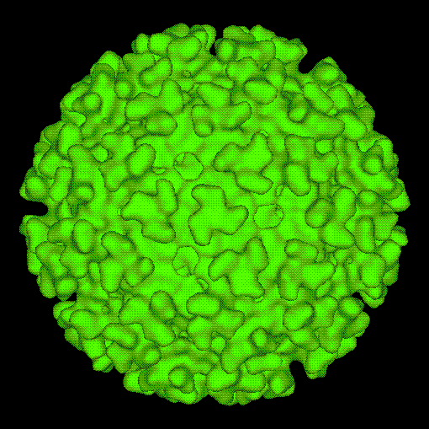
Western Equine Encephalitis is a viral disease that infects not only horses but humans as well. This virus is referred to as “Western” Equine Encephalitis because it is primarily seen to occur west of the Mississippi River. Western Equine Encephalitis virus is a Group IV +ssRNA virus, belonging to the togaviridea family in the alphavirus genus. Western Equine Encephalitis is also considered an arbovirus because it is an arthropod-borne virus that is spread by different species of mosquitoes. West Nile Virus, Eastern Equine Encephalitis, and others are important arboviruses that can cause significant damage.
Surface of an Alphavirus
Western Equine Encephalitis resides in vertebrate hosts. These hosts typically include birds, humans and horses. The natural host for Western Equine Encephalitis virus is the passerine bird. Passerine birds include blackbirds, jays, sparrows, finches, and warblers. From these hosts transmission of the virus occurs mainly near farmland or irrigated fields and by mosquitoes of the genera Culex and Culiseta. Horses and humans are infected when the Culex or Culiseta ingests the virus through the blood meal from a host bird and then subsequently bitten. Horses and humans are considered the dead-end host of Western Equine Encephalitis because while the virus may infect and cause disease, it does not replicate efficiently and does not produce viremia inhibiting further transmission. The virus replicates in the midgut epithelium of mosquitoes where they act as the vector for this disease. Western Equine Encephalitis is indirectly zoonotic meaning humans cannot contract the virus from horses nor birds, but only from mosquitoes. All alphaviruses are limited to their respective range of their arthropod vector. The rates of transmission correspond positively to the breading seasons for mosquitoes; Western Equine Encephalitis is spread most in the late spring through early fall. U.S. and Canada in 1941 had the most extensive epidemic of Western Equine Encephalitis that resulted in 300,000 cases of encephalitis in horses and mules and 3336 cases in humans. Since then, alphavirus encephalitis has been on the downfall in the United States. There have been 639 confirmed cases since 1964 with varying levels of clinical illnesses. From transiently infected individuals to severely infected patients paying cost ranged from $21,000 - $3,000,000.
In horses, Western Equine Encephalitis is a virus that causes disease in the central nervous system but not to the extent that Eastern Equine Encephalitis can. Clinical signs of Western Equine Encephalitis range considerably and include fever, anorexia, photosensitivity, disorientation, paralysis, and death and can be seen in horses from five days to three weeks after infection. Mortality rates in animals that show clinical signs range from 20% to 50%. Recovery from Western Equine Encephalitis can take place but permanent brain damage and abnormal reflexes can remain. For humans, most cases either cause a mild cold or are asymptomatic. Human clinical signs include fever, headache, nausea, vomiting, anorexia, and fatigue. Further damage can take place in the central nervous system potentially causing coma and even death. Recovery from Western Equine Encephalitis can cause permanent brain damage and has shown to in 5% to 30% of young adults. Younger children, especially children under the age of one, are at highest risk due to the lowered efficiency in immune response.

Bovine Respiratory Syncytial Virus

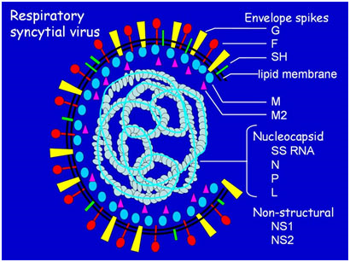
Bovine respiratory syncytial virus is a ssRNA virus in the family paramyxovirus and classified as a pneumovirus. Bovine respiratory syncytial virus got its named based on the cytopathic effects it creates, syncytial cell formation. Respiratory syncytial virus can infect sheep, goats, and humans in addition to cattle. In humans, respiratory syncytial virus causes increased damages in infants and young children. Bovine respiratory syncytial virus is common to the dairy and beef industry and causes an economic impact when animals are infected. It has been shown to be an important virus amongst the cattle industry because how frequently it occurs, the area of where it infects (lower respiratory tract), and the ability it gives bacteria to form a secondary infection. Bovine respiratory syncytial virus is distributed worldwide and indigenous to cattle. The virus typically causes respiratory disease that varies in severity and mainly amongst younger beef or dairy cattle such as the Holstein breed. Initially presented with Bovine respiratory syncytial virus, a cow is likely to contract a respiratory disease but with increased exposure comes increased immunity. Bovine respiratory syncytial virus causes high morbidity and has seen rates of fatality between 0% and 20%.
BRSV Structure
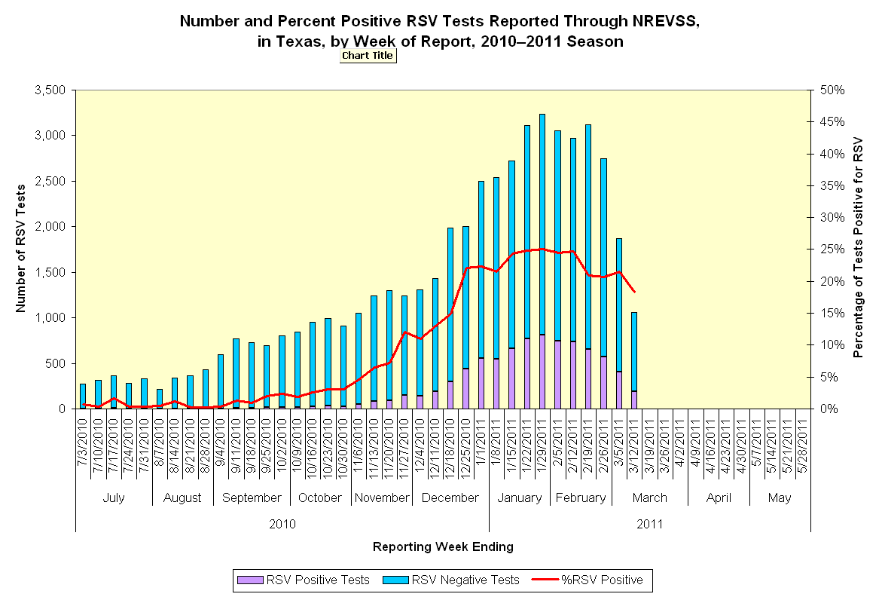

Prevalence of BRSV in Texas

Bovine respiratory syncytial virus is very common to the beef industry. It has been shown that almost 70% of calves that are involved in feedlot processes have been exposed to this virus. Bovine respiratory syncytial virus infects mainly agricultural areas around the world including North American. Younger cattle from the ages of two months to five months are at highest risk to show severe clinical negative effects. Once the animal is exposed to bovine respiratory syncytial virus, short term immunity is gained but the virus can infect again typically with less severe clinical symptoms. Transmission of the virus can be air-borne from shedding through nasal discharge. An animal can come in direct contact with bovine respiratory syncytial virus though physical contact of infected mucus or breathe in infected aerosol droplets. Close proximity is needed for the virus to spread by aerosol form due to the virus’s inability to survive long in the environment. Once the animal contracts the virus, it replicates in two cell types that are associated with lung epithelium.

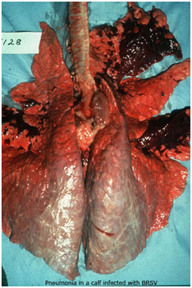
Bovine respiratory syncytial virus causes damage to the epithelium which can kill cell cilia and reduce the phagocytositic efficiency of the alveolar macrophages. The reduced efficiency of the macrophages makes the infected animal more prone to secondary bacterial lung infections such as bronchiolitis and pneumonia. Bovine respiratory syncytial virus can produce lesion found most abundantly in the lungs. Animals that progress to this stage of the disease exhibit difficult breathing, reduced food intake, fever, and nasal discharge.
Calf lung infected with BSRV

Lymphocytic Choriomeningitis Virus
Lymphocytic Choriomenigitis virus is a Group V -ssRNA virus that belongs to the family Arenaviridae and genus Arenavirus. This genus of virus is characterized by infecting rodents and occasionally humans. Lymphocytic Choriomenigitis virus can lead to Lymphocytic Choriomenigitis, aseptic meningitis, encephalitis, or meningoencephalitis. The viral infection infects the membranes that surround the brain and spinal cord. When the virus enters the body and creates an infection, there are characteristic abnormally high levels of lymphocytes. The virus also infiltrates the meninges and the choroid plexus and hence gets the name Lymphocytic Choriomenigitis virus because of it.
Lymphocytic Choriomenigitis Virus Structure
The natural host for Lymphocytic Choriomenigitis virus is the wild house mouse (Mus musculus) and is spread through this medium as well. From the mouse, other rodents such as pet mice, hamsters and guinea pigs can be infected and transmission to humans occurs more through these routes than directly from the house mouse. Animals such as rats, rabbits, dogs, pigs, and primates can become infected but less commonly than the preceding. Lymphocytic Choriomenigitis virus can be found and transmitted from feces, urine, saliva, semen, milk and blood of rodents that carry this virus. Consumption, direct contact, or inhalation of the aerosolized virus from any one of these sources can be the means for transmission to humans. There have not been any cases of human-to-human transmission except during vertical transmission where the fetus can contract the virus from its mother. Vertical transmission can happen if the mother is infected during the first two trimesters of pregnancy. If fetal contraction of the virus occurs, resulting problems such as microcephaly, choriomenigitis or fetal death can take place.
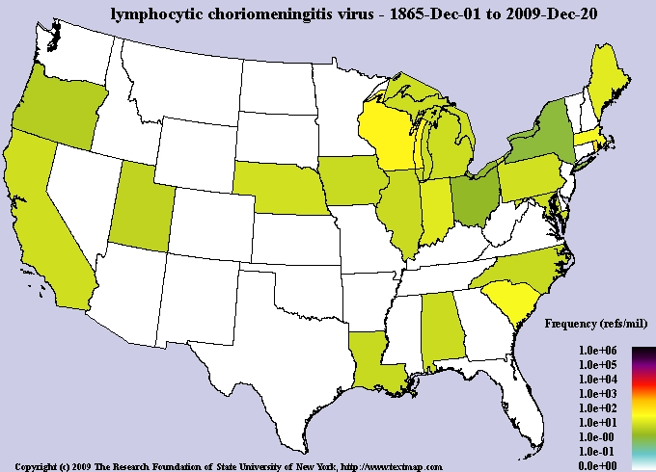
Lymphocytic Choriomenigitis virus is carried for life in most rodents that are infected. However, rodents do not show any clinical illnesses from the virus unlike the cases in humans. In healthy humans, Lymphocytic Choriomenigitis virus will be asymptomatic approximately 33% of the time. If the virus does cause a human to become ill, only half will develop mild symptoms and no neurological symptoms. However, some people do contract virus and show intensified negative effects. Lymphocytic Choriomenigitis will develop into a two phase disease, initial virema stage and secondary viremia stage. The initial virema stage lasts up to a week and is characterized by nonspecific flulike symptoms such as fever, muscle pain, vomiting, headaches, etc. Second stage viremia develops during recovery from stage one. Symptoms in this stage include severe headaches, encephalitis, fever, and or paralysis. There can also be a buildup of fluid in the brain from Lymphocytic Choriomenigitis causing hydrocephalus.
Lymphcytic Choriomeningitis Virus
1865 – 2009
http://www.textmed.com/heatmaps/unknown/lymphocytic-choriomeningitis-virus-us-heatmap.gif

Hantavirus (Hantavirus Pulmonary Syndrome)
Hantavirus Pulmonary Syndrome, first recognized in 1993, is characterized by incurable severe lung disease. The virus, Hantavirus, is a Group V –ssRNA virus that belongs to the family bunyaviridae and has no assigned order. Hantavirus enters the host cell by means of endocytosis. Attachment of the virus occurs when virions connect to the cellular receptors where it recognized and brought inside and the nucleocapsids are released into the cytoplasm. There are many different species of Hantaviruses that each correspond to a specific rodent or its main reservoir. These Hantaviruses cause different clinical effects as well. In Europe and Asia, the Hantavirus causes nonfatal renal syndrome and hemorrhagic fever, while in North America the Hantavirus causes a more serious illness called Hantavirus Pulmonary Syndrome where it has reached nearly a 50% mortality rate.
Hantavirus Structure
Hantavirus Pulmonary Syndrome has caused the most damage in the United States and can be found to reside in four different rodents. Hosts for Hantavirus Pulmonary Syndrome virus found in North America are the deer mouse, cotton rat, rice rat, and white-footed mouse. These mice can be found all around the U.S. but are typically located to certain regions mainly in brushy and wooded areas. Hantavirus Pulmonary Syndrome is contracted by humans commonly though means of inhalation of aerosolized virus from newly secreted rodent feces, urine, or saliva. Direct transmission has been identified from rodent bites as well as indirect transfer from contaminated hands into the oral or nasal regions.
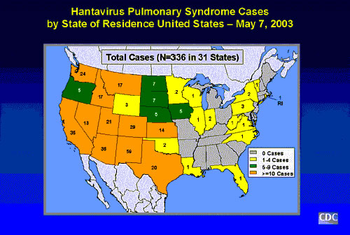
Hantavirus Pulmonary Syndrome virus is asymptomatic in animals. Rodents do not become ill from carrying the virus and has yet to show clinical symptoms in domestic and wild animals. The Hantavirus Pulmonary Syndrome virus does cause disease in humans but in rare occurrence because it does not cause high morbidity. Hantavirus Pulmonary Syndrome starts with flulike illnesses and can eventually progress to mortality if respiratory failure occurs. Initial symptoms are not specific to Hantavirus Pulmonary Syndrome and can be easily misdiagnosed. From day four to ten, after the signs appear, one can experience fluid entering the lungs causing shortness of breath and violent coughing. This is due to the virus attacking and damaging the capillary walls in the lungs which can, if sufficiently damaged, cause suffocation of the patient. Other signs of Hantavirus Pulmonary Syndrome can be acute respiratory distress syndrome, hypotension, and low blood oxygen levels.
Hantavirus Pulmonary Syndrome Cases
2003

Canine Distemper Virus
The canine distemper virus is a Group V -ssRNA virus. It belongs to the order monogavirals, family Paramyxoviridae, and genus morbillivirus. This enveloped virus is closely related to the viruses of measles and rinderpest. Canine distemper virus is highly contagious and is a systemic disease that infects mainly dogs and other animals worldwide. The virus is spread mainly through aerosol form of a secreted fluid from the infected host. Dogs can spread the disease for several months after being infected with canine distemper virus but close and recent proximity must take place for it to infect another host. The enveloped virus particle is unstable in the environment and is lipid solvent sensitive. If a dog does become infected with the virus, replication will initially take place in the lymphatic tissue of the respiratory tract. Viremia occurs as all of the lymphatic tissue becomes infected as well as the gastrointestinal tract, urogenital epithelium, optic nerves, and eventually the central nervous system.
Canine Distemper Virus Structure
Canine distemper virus causes a transient fever three to six days after it infects. Leukopenia and anorexia may accompany the fever but is typically suppressed days before the onset of a second fever. In this stage of the biphasic fever it will last less than a week and will now be accompanied by serious nasal discharge, mucopurulent ocular discharge, and acute encephalitis. If the virus becomes neurological and has infected the central nervous system, not only symptoms associated with CNS damage are there, hyperkeratosis can occur of the footpad, nose and areas near the eye. CNS damage from canine distemper virus can be seen when the animal begins having localized twitching of muscles, paralysis of the hind limb, convulsions seen with intense foaming at the mouth, and increasingly more severe seizures.
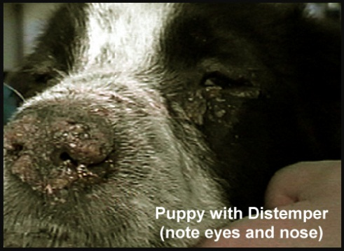
Preventable measures are made possible to stop canine distemper virus. In the past puppies were immunized against the distemper virus with the vaccine against measles because of the vast similarities with distemper. The available canine distemper virus vaccine is made of a modified live virus. This vaccine must be given early (five weeks) in the puppy’s life because for successful immunization there must be a lack of maternal antibody interference. Booster shots are recommended more frequently as a puppy, but when of one year of age a yearly booster shot is suggested.
Hyperkeratosis of eye and nose

References

-Bovine Respiratory Disease Complex

Wendorff Chase, Ritson-Bennett Tim, Schierman Adam, Gowan Troy, Rosing Justin
http://homepage.usask.ca/~vim458/virology/studpages2009/VirusWebsite/brsv.html

Center for Disease Control and Prevention (online)
-Surface of an Alphavirus
Division of Vector-Borne Infectious Diseases
National Center for Infectious
Fort Collins, Colorado
-Hantavirus Pulmonary Syndrome – United States: Updated Recommendations for Risk Reduction
Mills N. James., Corneli, Amy., Young, C. Joni., Garrison, E. Laurel., Kahn, S. Ali., Ksiazek, G. Thomas.
Division of Viral and Rickettsial Disease
National center for Infectious Diseases

-Handbook of Zoonoses: Identification and Prevention Edition 1
Colville, L. Joann., Berryhill, L. David. Mosby Pulishing, 2007.

-Principles and Practice of Infectious Diseases
Mandell L. Gerald., Bennett E. John., Dolin. Raphael
Harcourt Health Sciences 2000

