Virus Portfolio

Bovine Viral Diarrhea Virus
Canine Parvovirus Disease
Feline Leukemia Virus
Pseudorabies
Psittacine Beak and Feather Disease

By: Amanda Thomas

Bovine Viral Diarrhea Virus

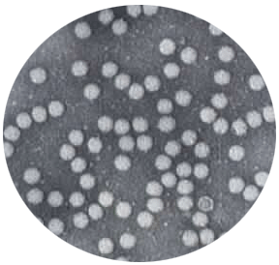
Family: Flaviviridae
Genus: Pestivirus

Virion Properties:
(+)ssRNA
Icosahedral
Spherical
50nm in diameter
Enveloped

The viral genome contains a single long open reading frame encoding for 10 proteins. Virions contain four protein for the Pestivirus encoded at the 5’ end and nonstructural protein at the 3’ end. Viral proteins include the nucleocapsid protein prM, the peplomer glycoproteins E1 and E2. The nonstructural of seven to eight includes RNA-dependent polymerase NS5 and NS3 which is responsible for cleavage of some polyproteins. These are indicated in the picture below.
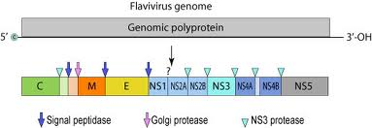
Replication:
BVDV replicates well in cell cultures in the host embryonic fibroblast or kidney cells. The virus enters the cell via receptor mediated endocytosis with the help of the Fc receptor helping with attachment. The virus then proceeds to replicate the cytoplasm of the cell. With the help of host cells processes postitve strained RNA is synthesized. The mRNA produced is the genome in which the polyprotein is formed and structural and nonstructural proteins will be made from. Virion assembly occurs in the endoplasmic reticulum. Fully formed virions appear in the cisternae of the endoplasmic reticulum and released via exocytosis or cell lysis.

Clinical Features:
There are two types of disease one being acute and noncytopathic (BVD) and the other being chronic and persistant cytopathic mucosal disease. Mucosal Disease (MD)

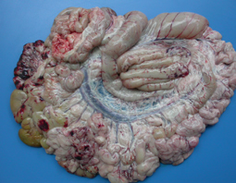
First described in 1946, the original BVDV was found in Ithaca, New York and showed the following characteristics:
Leukopenia
High fever
Depression
Diarrhea
Gastrointestinal erosions
Hemorrhages various tissues
Erosions in the GIT

There is also decreased milk production, Fetal abortions 10 to 3 months after the infection and lesions that resemble that of rinderpest.

Mucosal disease more severe and found later than the original BVDV in Canada. This type of Bovine Viral Disease Virus is thought to be a mutation in the original virus that has progessed to be a more severe form causing more issues. Because of it’s potential latency this virus can be spread to the fetus in a cow that was not known to have the disease and therefore was unknowingly bred. The classical clinical characteristics are:
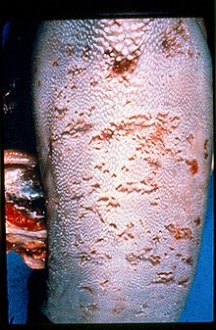
Fever
Anorexia
Depression
Profuse salivation
Nasal discharge
Gastrointestinal hemorrhages
Erosions
And ulcers
Bloody diarrhea
Lesions of the tongue
Prevention:
The transmission of the virus is through animal to animal contact, easily can be transmitted from herd to herd. Indirect contact through fomites and contaminated food through bodily fluids such as urine, oral and nasal secretions, amniotic fluid and from other infected cattle. The most prevalent transmission is from the persistently infected cow to uninfected cow. Persistently infected cattle include those in which the virus was transmitted in utero and the animal is now persistently infected surviving to breeding age and therefore can continue the cycle and infect the rest of the herd and other herds through breeding programs.
Immunization is the only control that is currently being used. Vaccines are administered 6-10 months of age when the passive immunity from the mother has waned.
Canine Parvovirus Disease

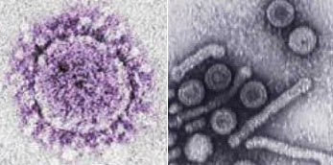
Family: Parvoviridae
Subfamily: Parvovirinae
Genus: Parvovirus

Virion Properties:
(-) ssDNA
25nm in diameter
Icosahedral
Non-enveloped

There are two forms of Canine Parvovirus one is Canine minute virus and the other is Canine Parvovirus 2 but we will talk mostly about Canine Parvovirus 2. Canine Parvovirus Disease is caused by canine parvovirus 2 first described in 1978 several countries. It has been suggested that virus spread the throughout the entire world within a matter of 6 months. It is considered a pandemic because of the susceptibility of the family Canidae which include domestic dogs, wolves, coyotes, etc. Canine Parvovirus 2 (CPV2) has a high rate of evolution because of nucleotide substitution similar to that of the influenza virus.

The genome contains a 5.2 kb of linear ssDNA and encapsidates only the negative-sense DNA strand. The genome has 6 to 10 terminal sequences that form hairpin structures. The capsid has viral proteins VP1, VP2, and VP3. VP1 and VP2 are formed by alternative splicing on the same mRNA, whereas VP3 is formed in full capsids.

Replication:

Viral replication takes place in the nucleus of the cell and requires host function such as that of the late S phase and G2 phase of the cell cycle. Nonstructural proteins are encoded on the 5’ end of the genome such as NS1 and serves to bind to DNA, acts as a helicase, endonuclease, and interferes with cellular DNA replication. The replication process is very complex.

Clinical Features:
There are three age-related syndromes:
Neonatal disease is rare
Myocarditis in pups results in sudden death
Leukopenia/enteritis in pups 8 to 12 weeks

Puppies are the most susceptible. Greater than 80% of adult dogs show no signs. In sever case dogs can die within 48 to 72 hours without any treatment.

Myocarditis syndrome:
Many puppies die with no symptoms being present. The virus affects the heart muscle causing necrosis associated with mononuclear infiltration. The myofibers of the heart are where this type of virus replicates and therefore the immune response to the heart muscle is what ultimately kills the animal. Other organs may be infected such as brain, liver, lungs this leads to lesion and hemorrhages. If the puppy does survive the infection it is likely to have lifelong cardiac problems.

Leukopenia/enteritis:
Dogs become infected through the oral-fecal route, infected soils, or fomites. Ingestion of the virus leads to replication in the lymphoid tissue in the throat which then lead to viremia. Infection of dividing cells such as bone marrow occurs and depletion of immune function occurs. Opportunistic bacteria affect the disease and can cause sepsis and systemic inflammatory response syndrome. Three to four days after the initial infection the dog sheds the virus through its feces. If the dog is infested with parasits the virus can be more deadly.
Symptoms usually show within 5 to 10 days and include:
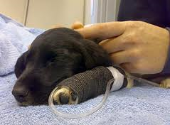
Lethargy
Vomiting
Fever
Diarrhea
Anemia
Secondary symptoms may be present as dehydration and secondary infections.

Prevention:
Vaccination is usually successful. Bleaching the area where an infected animal was, and quarantine of infected animals is necessary. Treatment includes IV fluids, anti-nausea medications, and antibiotics.

Feline Leukemia Virus

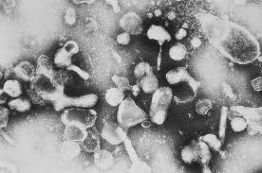
Family: Retroviridae
Genus: Gammaretrovirus

Virion Properties:
ssRNA
100 nm in diameter
Enveloped

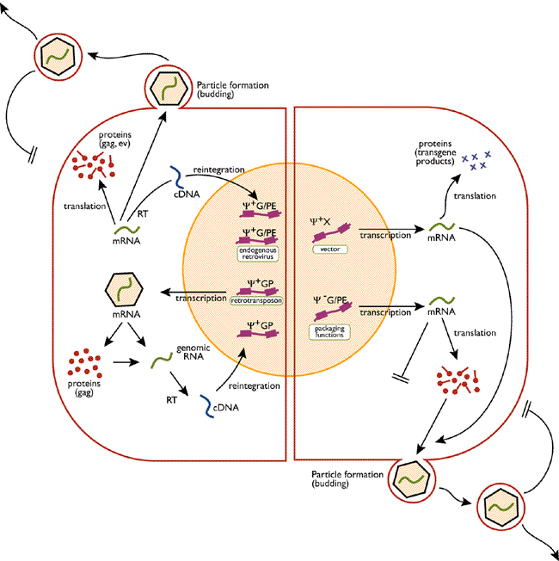
FeLV is an oncornavirus described in 1964 by W. Jarrett. It comprises of three genes: Gag which is structural, Pol which are enzymes, and Env which are envelope and transmembrane components. Replication is pictured below.

The stages of FeLV:
- Replication in local lymphoid tissue usually in the tonsillar and pharyngeal lymph nodes. This process occurs in the 2-12 day range.
- Dissemination in the circulating lymphocytes and monocytes. This also occurs in the 2 to 12 day range.
- Replication in the spleen, more lymph nodes, and the gut-associated lymphoid tissue. This also occurs in the 2 to 12 day range
- Finally replication in the bone marrow and intestinal epithelial crypts occurring in the 2 to 6 week range
- This leads to peripheral viremia and dissemination in the infected bone marrow. This occurs in the 4 to 6 week range
- Disseminated epithelial cell infection occurs with the virus being secreted in the saliva and tears. Occurring in the 4 to 6 week range.

There are three antigenic types based on the envelope antigens. There are A, B, and C. Immunosuppression is the ultimate progression of the virus; it infects the CD4+ and CD8+ T-lymphocytes, B-lymphocytes, and myeloid cells.

Transmission of the virus is horizontal from cat to cat. This action occurs through the bodily fluid usually that of saliva and tears. The saliva has the highest amount and is what causes the best means to infect others through the act of grooming, and biting.

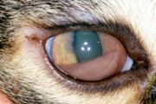
Clinical signs:
Ocular disease
Enlarged lymph nodes
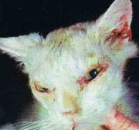
Anorexia
Weight loss
Gingivitis
Cystitis
Persistent diarrhea
Seizures
Abortions in queens
Secondary infections are common with fungal and bacterial. There are also systemic infections like leukemia, lymphoma, etc.
Blood transfusions and interferon are used for the treatments. Vaccination should be done especially for that of the indoor-outdoor cat.

Pseudorabies

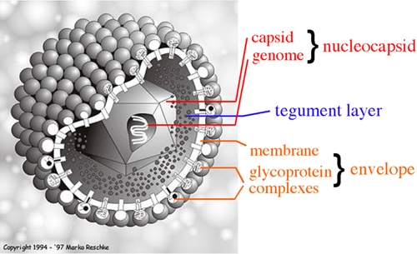
Family: Herpesviridae
Subfamily: Alphaherpesvirinae
Genus: Varicellovirus

Virion Properties:
dsDNA
150 nm
Icosahedral
Enveloped

History:
The earliest reports of the virus were in 1813 in the United States of America. The reports were in that od cows with severe itching, therefore they coined the term “mad itch”. In 1902 a Hungarian veterinarian Dr. Aujeszky isolated the virus from a cat, ox, and cat. The name Pseudorabies was coined from the the symptoms associated with the disease.

Importance:
The disease is economically important for the swine industry, since the disease’s natural host is swine. The disease can result in trade restrictions from the regions in which the disease is endemic. The clinical aspects also tend to put a damper on reproduction and survival of piglets.
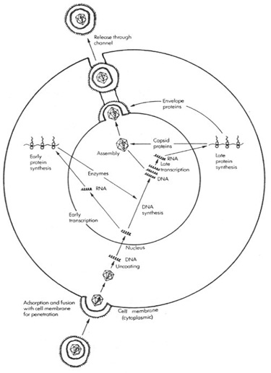
Replication:

Clinical Features:
The incubation period is 2 to 4 days in the suckling piglets and 3 to 6 days in the weaned and adult pigs.
In the pigs less than a week old there is high mortality and symptoms are as follows:
- Fever
- Listlessness
- Anorexia
- Tremors
- Paddling
- Seizures
Once onset of CNS symptoms, death occurs within 24 to 36 hours)

Weaned or adult pigs have more of flu-like symptoms and include:
  - Fever
  - Anorexia
  - Weight loss
  - Coughing
  - Sneezing
  - Dyspnea
Recovery occurs within after 5 to 10 days. In the pregnant sows reabsorb fetuses, abort, and have premature births.

In cattle and sheep
  - Highly fatal
  - 1st symptom pruritis (itch) on a patch
  - Progresses to self-mutilation
  - Weakness
  - Convulsions
  - Rapid shallow breathing

Cats and dogs are similar to that of the cattle and sheep but have additional neurological signs as well as pharyngeal paralysis and profuse salivation. Death occurs in 1 to 2 days.

Transmission:
This virus transmits between pigs by saliva usually nose-to-nose, aerosol, carcasses and fomites. Aerosol forms are infectious in the air for up to 7 hours with a humidity lower than 55%. Virus can be present more than 2 weeks in milk, urine, and other secretions. There are also latent infections.
Prevention:
This includes testing of new animals coming in the herd and for breeding. Biosecurity measure with bleach and decontamination is also recommended. Domestic herds should be housed far away from environments near the feral swine, since transmission can occur from close vicinity. Vaccination is possible that helps protect against clinical signs. The USDA pseudorabies eradication program is a voluntary program established in 1989. It is coordinated by the USDA’s Animal and Plant Health Inspection Service (APHIS) and include surveillance, herd monitoring and herd cleanup.

Psittacine Beak and Feather Disease

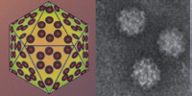
Family: Circoviridae
Genus: Circovirus

Virion Properties:
(+)ssDNA
17 nm in diameter
Spherical
Icosahedral

Characteristically the virions appear in infected cells as a “string of pearls”. It employs an ambisense transcription strategy with some genes being coded for viral sense DNA and other for complementary strand. It has three open reading frames with one major capsid protein.
Replication:
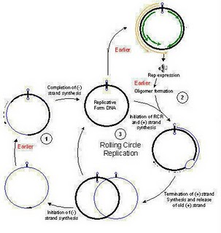
Viral replication occurs in the nucleus in the host’s cell, similar to the parvovirus. It depends on the cellular proteins that are produced in the S phase of the host cell cycle. The replication of the genome occurs via a rolling circle originating at the stem-loop structure.
Clinical Features:
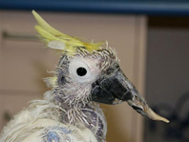
Psittacine beak and feather Disease (PBFD) is a very debilitating disease for the avian species of cockatoos, parrots, and budgerigars. The most susceptible are birds that are less than 5 years of age and those who are coming into their first molt. Classical signs include:
  - Feather loss
  - Abnormal pin feathers being clubbed or stunted
  - Abnormal mature feather such as blood in the shaft
  - Various beak malformations
  - Depression

The disease can also affect the liver, brain, and immune system causing susceptibility of infection. Premature deaths occur because of secondary infections of fungus, bacteria, or parasites.

Transmission of the virus is from one individual to another primarily thorugh direct contact, but also through aerosol, crop-feeding, fecal materials, feather dust as well as fomites.

Prevention:
Strict isolation of diseased birds, and DNA testing for new birds that may be latently infected.
References

- Aujeszky’s Disease. Center for Food Security and Public Health. Iowa State University. 2006 www.aphis.usda.gov › Animal Health › Animal Diseases
- Bovine respiratory disease. Accessed on-line at http://homepage.usask.ca/~vim458/virology/studpages2009/VirusWebsite/bvdv.html
- Bovine Viral Diarrhea. Wikipedia. Accessed April 2011. http://en.wikipedia.org/wiki/Bovine_virus_diarrhea
- Kelling C.L. (2004). Evolution of Bovine Viral Diarrhea Virus Vaccines. Veterinary Clinics Food Animal Practice. 20: 115-129
- Merck Veterinary Manual. Acessed on-line at http://www.merckvetmanual.com/mvm/index.jsp
- Murphy, F. Veterinary Virology. San Diego, CA: Academic Press, 1999.
- Pseudorabies (Aujeszky’s Disease).Pork Industry Handbook, Perdue University.
- Pseudorabies FAQ pdf. US Department of Agriculture. www.aphis.usda.gov/animal.../pseudorabies/.../pseudorabies_faq.pdf
- Pseudorabies. Wikipedia. en.wikipedia.org/wiki/Pseudorabies
- Sagar M. Goyal, Julia F. Ridpath. Bovine Viral Diarrhea Virus: Diagnosis Mngmt. 1993.
- Viral Characteristics. April 2007. Accessed April 2011. http://homepage.usask.ca/~vim458/virology/studpages2007/AshleyB/bvdvvirus.html

